Project Report
Nutrition Assistant using MERN stack

TEAM MEMBERS
1.Gangadhar Ganji (Team Lead)
2. Siri Giddi
3. Bhadravathi Koppula
4.Areti Phaneendra
5.Bhargav Attili

1. INTRODUCTION

1.1 Project Overview

Nutrition plays a vital role in maintaining good health, preventing diseases, and improving overall quality of life. However, many individuals struggle to maintain balanced diets due to busy lifestyles, lack of nutritional knowledge, and difficulty in tracking daily food intake. As awareness of healthy living continues to grow, there is an increasing need for intelligent digital solutions that can assist users in managing their nutrition, monitoring their health, and making informed dietary choices based on personalized recommendations.

The Nutrition Assistant using MERN Stack project is designed to provide a comprehensive web-based platform for personalized nutrition management and health monitoring. The application is developed using the MERN Stack (MongoDB, Express.js, React.js, and Node.js) to deliver a responsive, secure, and scalable solution. It enables users to calculate their Body Mass Index (BMI), estimate daily calorie requirements, track nutritional intake, manage meal plans, and receive AI-powered food recommendations through an intuitive and interactive dashboard.

The project focuses on analyzing users' health profiles, dietary preferences, calorie consumption, and nutritional intake to provide personalized meal suggestions and health insights. Interactive dashboards, charts, progress trackers, and nutrition reports allow users to monitor their daily, weekly, and monthly health progress while encouraging healthier eating habits. The system also includes secure user authentication, meal logging, nutrition analysis, and comprehensive progress tracking to improve the overall user experience.

This application is designed to benefit a wide range of users with different health and fitness goals. Individuals seeking a healthier lifestyle can monitor their nutrition and receive personalized meal recommendations. Fitness enthusiasts can track calories, macronutrients, and progress toward their fitness objectives. Dieticians and nutritionists can utilize the platform to monitor dietary habits and provide evidence-based nutritional guidance. Healthcare professionals can also leverage nutritional insights to support preventive healthcare and encourage healthier lifestyle choices among patients.

The project demonstrates how modern web technologies, database management, data analysis, and AI-driven recommendation techniques can transform nutritional information into meaningful and actionable health insights. By integrating interactive dashboards, personalized recommendations, and real-time nutrition tracking within a single web application, the Nutrition Assistant using MERN Stack promotes informed dietary decisions, healthier lifestyles, and long-term wellness through an intelligent and user-friendly digital platform.

1.2 Purpose

The purpose of the Nutrition Assistant using MERN Stack project is to provide a comprehensive and user-friendly web application that helps individuals monitor their nutritional intake, manage healthy eating habits, and make informed dietary decisions through personalized recommendations. The project aims to transform user health and nutrition data into meaningful insights using interactive dashboards, progress tracking, and AI-powered meal recommendations, enabling users to better understand and improve their overall health.

This project is designed to support healthier lifestyle choices for a wide range of users, including health-conscious individuals, fitness enthusiasts, dieticians, nutritionists, and healthcare professionals. Users can calculate their Body Mass Index (BMI), estimate daily calorie requirements, track their nutritional intake, and receive personalized meal plans based on their health goals and dietary preferences. Dieticians and healthcare professionals can utilize the application to monitor user progress and provide evidence-based nutritional guidance, while individuals can develop healthier eating habits and achieve their fitness and wellness objectives.

The project also demonstrates the practical application of modern web development technologies, database management, health data analysis, and AI-powered recommendation techniques in addressing real-world nutrition and wellness challenges. By integrating secure user authentication, nutrition tracking, interactive dashboards, personalized meal planning, and progress monitoring into a single MERN Stack application, the project makes nutrition management more accessible, efficient, and effective, ultimately promoting healthier lifestyles and long-term well-being.2. IDEATION PHASE

2.1 Problem Statement
Maintaining a healthy lifestyle requires proper nutrition, balanced meal planning, and regular monitoring of dietary habits. However, many individuals struggle to track their daily calorie intake, nutritional values, and overall health due to busy schedules, lack of nutritional awareness, and the absence of personalized guidance. Existing nutrition tracking methods are often manual, time-consuming, or provide generic recommendations that do not consider individual health conditions, dietary preferences, or fitness goals.

Traditional health and diet management approaches offer limited personalization and make it difficult for users to monitor their nutritional intake, analyze health progress, and make informed dietary decisions. As a result, individuals may develop unhealthy eating habits, experience nutritional deficiencies, or fail to achieve their health and fitness objectives due to the lack of accurate, data-driven insights and continuous progress tracking.

This project addresses these challenges by developing a Nutrition Assistant using the MERN Stack, an interactive web application that provides secure user authentication, BMI and calorie calculations, daily nutrition tracking, personalized meal planning, AI-powered food recommendations, and health progress monitoring. The application transforms user health and nutrition data into meaningful insights through interactive dashboards and reports, enabling users to make informed dietary decisions, improve their eating habits, and achieve their long-term health and wellness goals.

2.2 Empathy Map Canvas
User: Health-Conscious Individual / Fitness Enthusiast / Dietician
Says | Thinks
"How many calories should I eat today?" | Am I getting the right nutrients?
"I want a personalized meal plan." | Which foods are healthiest for my goals?
"I need an easy way to track my nutrition." | How can I improve my diet and stay consistent?
Does Feels

Does Feels

Tracks daily meals and calorie intake. Motivated to live a healthier lifestyle.
Calculates BMI and monitors health progress. Confused by conflicting nutrition advice.
Uses nutrition apps and follows healthy eating plans. Encouraged when seeing measurable progress toward fitness goals.

2.3 Brainstorming

During the brainstorming phase, several ideas were discussed to determine the most effective way to help users manage their nutrition, monitor their health, and achieve healthier lifestyles. The focus was on developing an intelligent web application that simplifies nutrition tracking, provides personalized recommendations, and enhances user engagement through interactive features.

The following ideas were considered:

Develop a secure user registration and authentication system.

Calculate Body Mass Index (BMI) and daily calorie requirements.

Track daily calorie intake and nutritional values.

Create personalized meal plans based on user preferences and health goals.

Provide AI-powered food and meal recommendations.

Develop an interactive health dashboard to visualize nutrition and fitness progress.

Monitor daily, weekly, and monthly nutrition statistics through charts and reports.

Build an admin panel to manage users, food items, and nutrition data.

Deploy the application as a responsive web application using the MERN Stack.

Maintain the project source code, version control, and documentation using GitHub.

After evaluating these ideas, an intelligent Nutrition Assistant using the MERN Stack with personalized nutrition tracking, AI-based meal recommendations, interactive health dashboards, and progress monitoring was selected as the most effective solution for promoting healthy eating habits and supporting informed dietary decisions.

3. REQUIREMENT ANALYSIS

3.1 Customer Journey Map
The customer journey map illustrates how different users interact with the Nutrition Assistant to achieve their health and fitness goals.
Stage | Health-Conscious Individual | Dietician / Nutritionist | Fitness Enthusiast
Need | Maintain a healthy diet and improve overall wellness. | Monitor clients' nutrition and provide personalized diet plans. | Achieve fitness goals by tracking calories, nutrients, and meal plans.

Stage | Health-Conscious Individual | Dietician / Nutritionist | Fitness Enthusiast
Search | Access the Nutrition Assistant dashboard and create a profile. | Review clients' nutrition records and health reports. | Access nutrition dashboard and fitness tracking features.
Analysis | Analyze daily calorie intake, BMI, and nutritional values. | Evaluate clients' dietary habits and health progress. | Compare calorie consumption, macronutrients, and workout nutrition.
Decision | Choose suitable meal plans and healthy food options. | Recommend personalized diet plans and nutrition guidance. | Select meal plans that support fitness and performance goals.
Outcome | Improved health, balanced nutrition, and healthier eating habits. | Better client health management and personalized nutritional support. | Enhanced fitness performance, consistent progress, and achievement of health goals.

3.2 Solution Requirement

Functional Requirements

Allow users to register, log in securely, and manage their profiles.

Calculate Body Mass Index (BMI) and daily calorie requirements.

Track daily food intake, calories, and nutritional values.

Generate personalized meal plans based on user preferences and health goals.

Provide AI-powered food and meal recommendations.

Display an interactive health dashboard with nutrition statistics and progress reports.

Monitor daily, weekly, and monthly nutrition and fitness progress.

Allow administrators to manage users, food items, and nutrition data.

Enable users to update their health information and meal records.

Store and retrieve user data securely using MongoDB.

Non-Functional Requirements

User-friendly and intuitive interface.

Fast response time and efficient application performance.

Secure user authentication and data protection.

Accurate BMI, calorie, and nutrition calculations.

Responsive design compatible with desktops, tablets, and mobile devices.

High availability, scalability, and easy maintenance.

Reliable data storage using MongoDB.

Version control using Git and GitHub.

Easy deployment on cloud platforms such as Vercel, Render, or AWS.

Maintainable and modular MERN Stack architecture.

Software Requirements
- Visual Studio Code (VS Code) – Code editor for developing the MERN Stack application.
- React.js – Frontend library for building the user interface.
- Node.js – JavaScript runtime environment for server-side development.
- Express.js – Backend framework for building RESTful APIs.
- MongoDB – NoSQL database for storing user profiles, nutrition data, and meal records.
- Git – Version control system for source code management.
- GitHub – Repository hosting and collaborative development.
- Postman – API testing and debugging tool.
- Web Browser (Google Chrome / Microsoft Edge) – For accessing and testing the web application.
- Vercel / Render – Cloud platform for deploying the frontend and backend services (optional, depending on your deployment).

Hardware Requirements
- Processor: Intel Core i3 or above (Intel Core i5 or AMD Ryzen 5 recommended)
- RAM: Minimum 4 GB (8 GB or above recommended)
- Storage: Minimum 10 GB free disk space (SSD recommended)
- Internet Connection: Required for application deployment, API communication, and database access
- Operating System: Windows 10/11, Linux, or macOS
- Display: Minimum resolution of 1366 × 768 for optimal user experience

3.3 Data Flow Diagram
Level-0 Data Flow Diagram

+---------------------------+
| User Input |
| (Registration, Login, |
| Health Details, Meals) |
+---------------------------+
|
v
+---------------------------+
| Data Processing |
| (Validation & Analysis) |
+---------------------------+
|
v
+---------------------------+
| MERN Application |
| (BMI, Calories, AI |
| Recommendations) |
+---------------------------+
|
v
+---------------------------+
| MongoDB Database |
| (User & Nutrition Data) |
+---------------------------+
|
v
+---------------------------+
| Interactive Web Interface |
| (React.js Dashboard) |
+---------------------------+| v
+---------------------------+
| End Users |
| Health-Conscious Users |
| Dieticians |
| Fitness Enthusiasts |
+---------------------------+
+

+

3.4 Technology Stack
Technology | Purpose
React.js | Building the interactive and responsive user interface
HTML5 | Structuring web pages
CSS3 | Styling and designing the user interface
JavaScript (ES6+) | Implementing client-side functionality and interactivity
Node.js | Server-side JavaScript runtime environment
Express.js | Building RESTful APIs and backend services
MongoDB | Storing user profiles, nutrition records, meal plans, and health data
Mongoose | Object Data Modeling (ODM) for MongoDB
JWT (JSON Web Token) | Secure user authentication and authorization
Git | Version control and source code management
GitHub | Source code hosting and collaboration
Visual Studio Code | Code development and debugging
Postman | API development, testing, and debugging
Vercel / Render | Deployment and hosting of the MERN Stack application
Web Browser (Google Chrome / Microsoft Edge) | Running and testing the web application
Vercel | Deployment and hosting of the project website
Web Browser | Viewing dashboards and website

4. PROJECT DESIGN
4.1 Problem Solution Fit
The agricultural sector generates a large volume of crop production data every year, making it difficult for stakeholders to analyze and extract meaningful insights using traditional methods.
Farmers often struggle to identify suitable crops and seasons, policymakers require reliable data for planning and resource allocation, and investors need historical trends to make informed investment decisions.
The proposed solution addresses these challenges by developing an interactive data visualization platform using Tableau. Historical agricultural data from 1997–2021 is cleaned, processed, and transformed into interactive dashboards and stories. Users can analyze crop production based on state, season, crop type, and year, enabling better understanding of agricultural trends and supporting data-driven decision-making.
This solution simplifies complex datasets through visual analytics, making agricultural information more accessible, interactive, and actionable for different stakeholders.

4.2 Proposed Solution
- The proposed solution is a Tableau-based Business Intelligence system that analyzes India's agricultural crop production data from 1997 to 2021. The system converts raw agricultural data into interactive dashboards and visual stories, allowing users to explore production trends, seasonal variations, regional performance, and crop-wise analysis.
- The solution includes the following features:
- • Interactive dashboards with filters for crop, state, season, and year.
- • KPI cards displaying important agricultural statistics.
- State-wise and crop-wise production analysis.
- Seasonal production comparison (Kharif, Rabi, and Zaid).
- Year-over-year production trend analysis.
- Tableau Story for guided visualization of insights. • Responsive web interface deployed using
Vercel.
- GitHub repository for source code and project documentation.
This solution enables farmers, policymakers, researchers, and investors to gain meaningful insights and make informed decisions based on historical agricultural data.

4.3 Solution Architecture
The overall architecture of the system consists of multiple stages, beginning with user interaction and ending with personalized nutrition insights delivered through an interactive web application.

User Registration & Login
(Health Profile & Preferences)
│
▼
Data Validation & Processing
(Node.js & Express.js)
│
▼
MongoDB Database
(User Profiles • Nutrition Data • Meal Records)
│
▼
Application Logic
(BMI Calculator • Calorie Calculator • AI Meal Recommendation)
│
▼
React.js Web Application
(Health Dashboard • Nutrition Tracking • Progress Reports)
│
▼
Deployment
(GitHub + Vercel/Render)
│
▼
End Users
┌───────────────────────┬──────────────────────┬──────────────────────┐
│ Health-Conscious Users │ Dieticians & Nutritionists │ Fitness Enthusiasts │
└───────────────────────┴──────────────────────┴──────────────────────┘

Architecture Description
- Data Collection: Agricultural crop production data (1997–2021) is collected from the dataset.
- Data Preprocessing: The dataset is cleaned, organized, and prepared using Microsoft Excel.
- Data Visualization: Tableau is used to create interactive dashboards, charts, maps, KPI cards, and stories.
- Website Integration: The Tableau dashboards are embedded into a responsive website developed using HTML, CSS, Bootstrap, and JavaScript.
- Deployment: The website and project source code are deployed using Vercel and GitHub for public access.
- End Users: Farmers, government policymakers, researchers, and agribusiness investors use the platform to explore insights and support data-driven decision-making.

5. PROJECT PLANNING & SCHEDULING

5.1 Project Planning
Day | Activity
Day 1 | Requirement analysis, problem understanding, and dataset collection
Day 2 | Data cleaning and preprocessing using Microsoft Excel
Day 3 | Dashboard design and visualization development in Tableau
Day 4 | Tableau Story creation and dashboard refinement
Day 5 | Website development and Tableau dashboard integration
Day 6 | Testing, debugging, and deployment using GitHub and Vercel
Day 7 | Documentation, project report preparation, and final submission

Project Workflow
Requirement Analysis
↓
Dataset Collection
↓
Data Cleaning & Preprocessing
↓
Dashboard Development (Tableau)
↓
Story Creation
↓
Website Development
↓
Testing & Deployment
↓
Documentation & Final Submission

Milestones Achieved
• ✔ Requirement analysis completed.
• ✔ System architecture and database design completed.
• ✔ MERN Stack development environment configured successfully.
• ✔ Secure user authentication and authorization implemented.
• ✔ BMI Calculator and Calorie Calculator developed.
• ✔ Daily nutrition tracking and personalized meal planner implemented.
• ✔ AI-powered food recommendation module integrated.
• ✔ Interactive health dashboard and progress tracking completed.
• ✔ MongoDB database integrated successfully.
• ✔ Responsive web application developed using React.js.
• ✔ Backend APIs developed using Node.js and Express.js.
• ✔ Project deployed using GitHub and Vercel/Render.
• ✔ Testing, debugging, and performance optimization completed.
• ✔ Documentation and final project report completed.

6. FUNCTIONAL AND PERFORMANCE TESTING
Testing was conducted to ensure that the Nutrition Assistant using MERN Stack functions correctly, securely, and efficiently while providing a smooth and user-friendly experience. Both functional testing and performance testing were performed to verify the reliability of the application's core features, including user authentication, BMI calculation, calorie estimation, nutrition tracking, AI-powered meal recommendations, dashboard visualization, and database operations. The application was also tested for responsiveness across different devices and web browsers to ensure consistent performance, secure data handling, and accurate health-related calculations.

6.1 Performance Testing
Performance testing was carried out to evaluate the responsiveness, stability, security, and usability of the Nutrition Assistant using MERN Stack under normal operating conditions. The application was tested to ensure fast page loading, efficient API response times, secure user authentication, accurate BMI and calorie calculations, reliable nutrition tracking, and smooth interaction with the MongoDB database. The results indicate that the system performs efficiently, providing quick access to personalized meal recommendations, health dashboards, nutrition reports, and progress tracking while maintaining a responsive and seamless user experience across different devices and web browsers.

Performance Test Cases

Test Case Expected Result | Actual Result | Status
Home page opens correctly Website loads successfully | Website loaded successfully | Pass
Tableau dashboard loading Dashboard loads without errors | Dashboard loaded correctly | Pass
Story pages navigate smoothly Tableau Story navigation | Navigation successful | Pass
Filters update visualizations correctly Dashboard filters | Filters functioned properly | Pass

Interactive charts | Charts respond to user interaction | Interactive response verified | Pass
State, Crop, and Season selection | Displays accurate filtered results | Accurate results displayed | Pass
Cross-device compatibility | Website works on desktop and mobile browsers | Responsive layout verified | Pass
GitHub repository accessibility | Repository opens successfully | Repository accessible | Pass
Website response time | Pages load within acceptable time | Response time satisfactory | Pass
Data accuracy | Visualizations match the dataset | Data verified successfully | Pass

Performance Summary
- The web application loads efficiently on modern web browsers.
- User registration, login, and authentication function correctly and securely.
- BMI and daily calorie calculations produce accurate results.
- Nutrition tracking and meal logging operate smoothly without data loss.
- AI-powered meal recommendations are generated accurately based on user inputs.
- The interactive health dashboard displays nutrition statistics and progress reports correctly.
- The responsive web design ensures seamless accessibility across desktops, tablets, and mobile devices.
- MongoDB stores and retrieves user data securely and efficiently.
- The deployed application and GitHub repository are publicly accessible for project demonstration and evaluation.
Overall, the testing results confirm that the Nutrition Assistant using the MERN Stack meets the required functional and performance standards, providing users with a secure, reliable, interactive, and efficient platform for tracking nutrition, managing health, receiving personalized meal recommendations, and monitoring their overall wellness.

7. RESULTS
The Nutrition Assistant using MERN Stack project was successfully developed and implemented using the MERN Stack (MongoDB, Express.js, React.js, and Node.js) to provide a comprehensive web-based platform for nutrition management and health monitoring. The application enables users to monitor their daily nutritional intake, calculate Body Mass Index (BMI), estimate calorie requirements, receive personalized meal recommendations, and track their health progress through an interactive and user-friendly dashboard.
The developed system allows users to securely register, manage their health profiles, log daily meals, and monitor calorie and nutrient consumption. Features such as BMI calculation, calorie tracking, AI-powered food recommendations, personalized meal planning, and progress tracking help users understand their dietary habits, make informed nutritional decisions, and work toward their health and fitness goals.
The application provides a responsive and intuitive user interface, while the backend efficiently manages user authentication, data processing, and secure storage using MongoDB. Interactive dashboards and progress reports present nutritional information in a clear and meaningful manner, enabling users to monitor their overall wellness and maintain healthy eating habits effectively.
The project was successfully deployed, allowing users to access the application through a modern web browser from various devices. Overall, the system demonstrates the effective use of modern web technologies, database management, and intelligent nutrition analysis to provide a secure, scalable, and user-friendly platform that promotes healthier lifestyles, informed dietary decisions, and long-term well-being.

7.1 Output Screenshots
The following screenshots demonstrate the successful implementation of the project:

Figure 7.1: Home Page

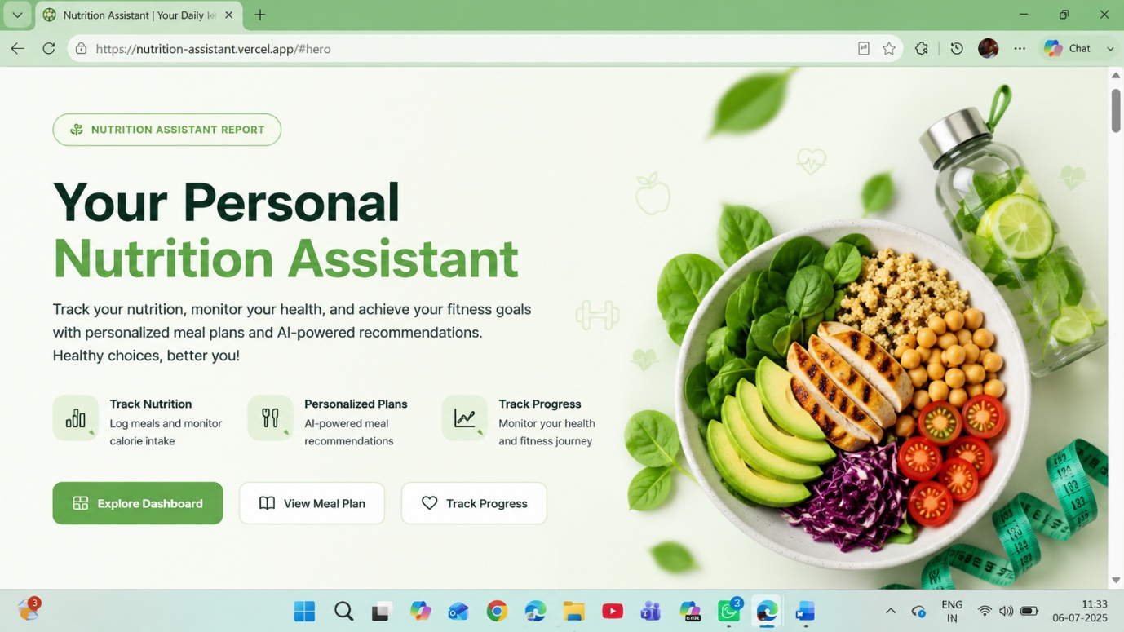

Figure 7.2: Dashboard Overview

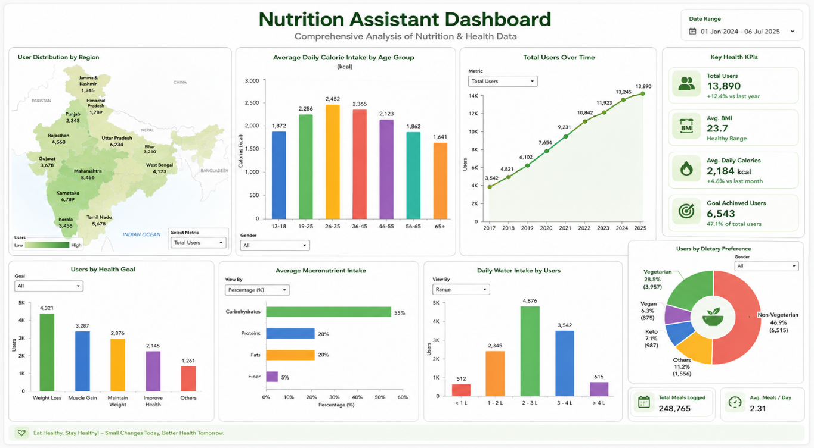

Figure 7.3:
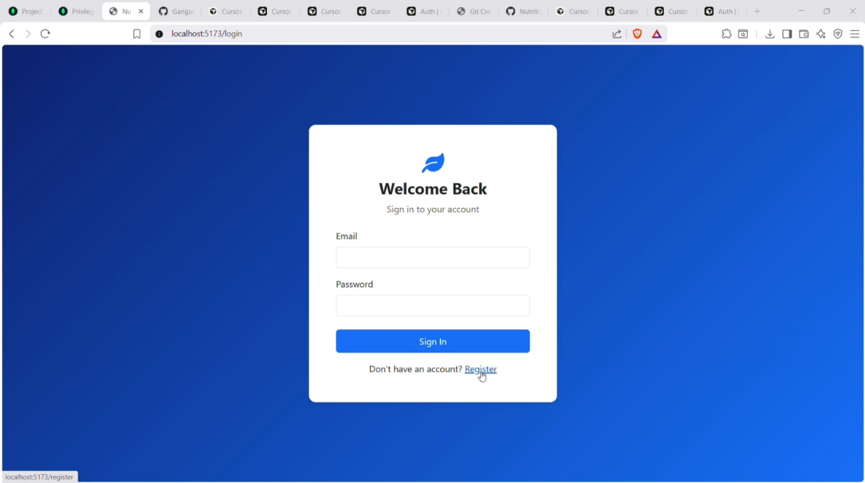

Figure 7.4:

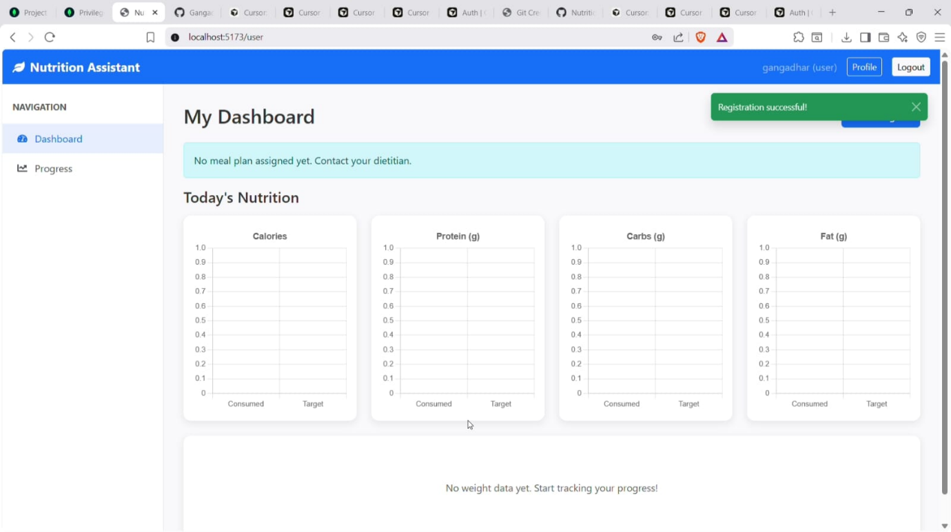

7.5:

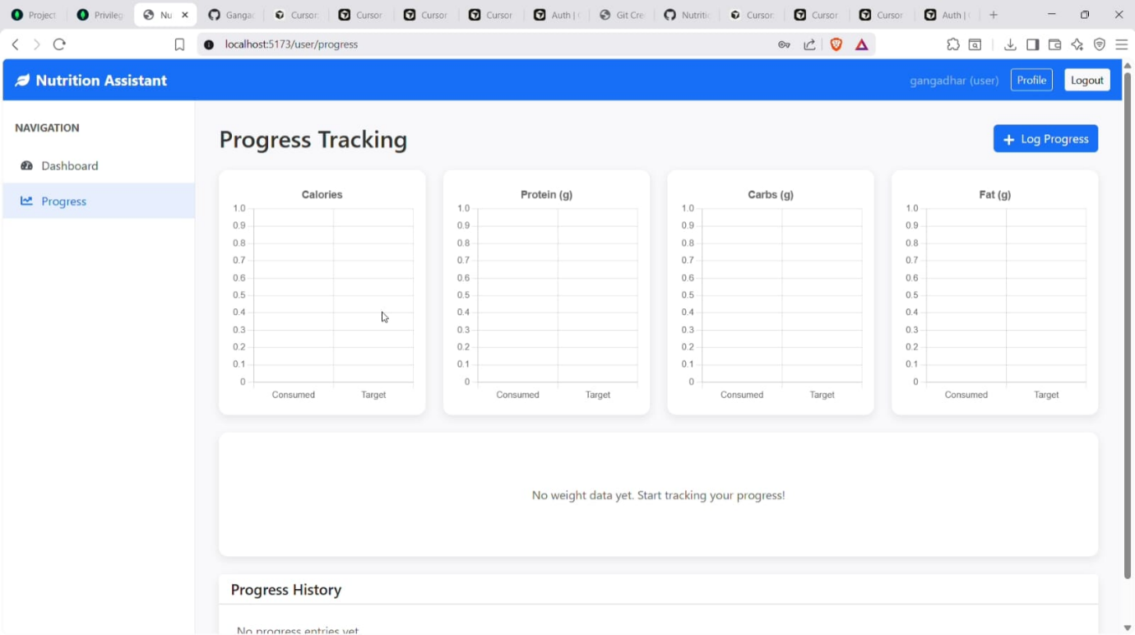

Figure 7.6:
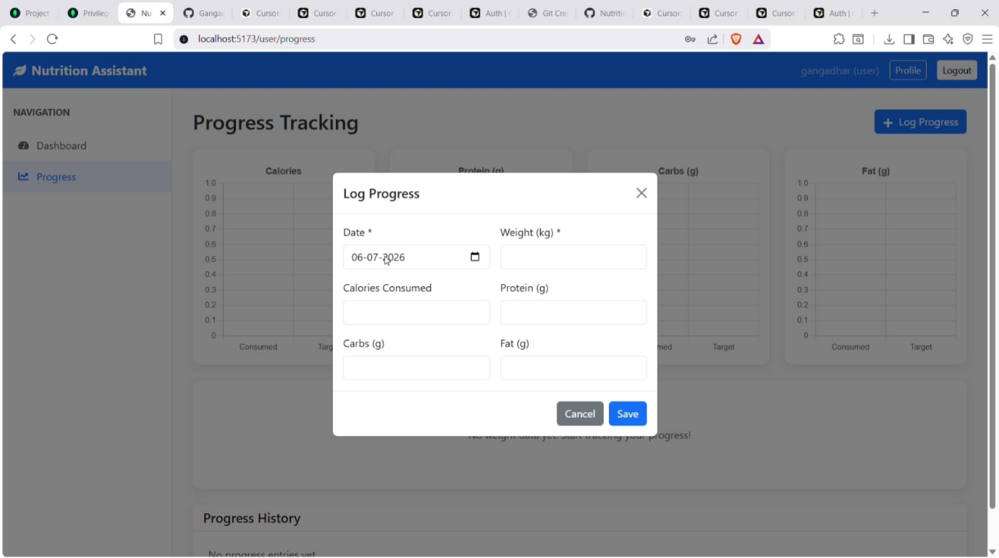

7.7:

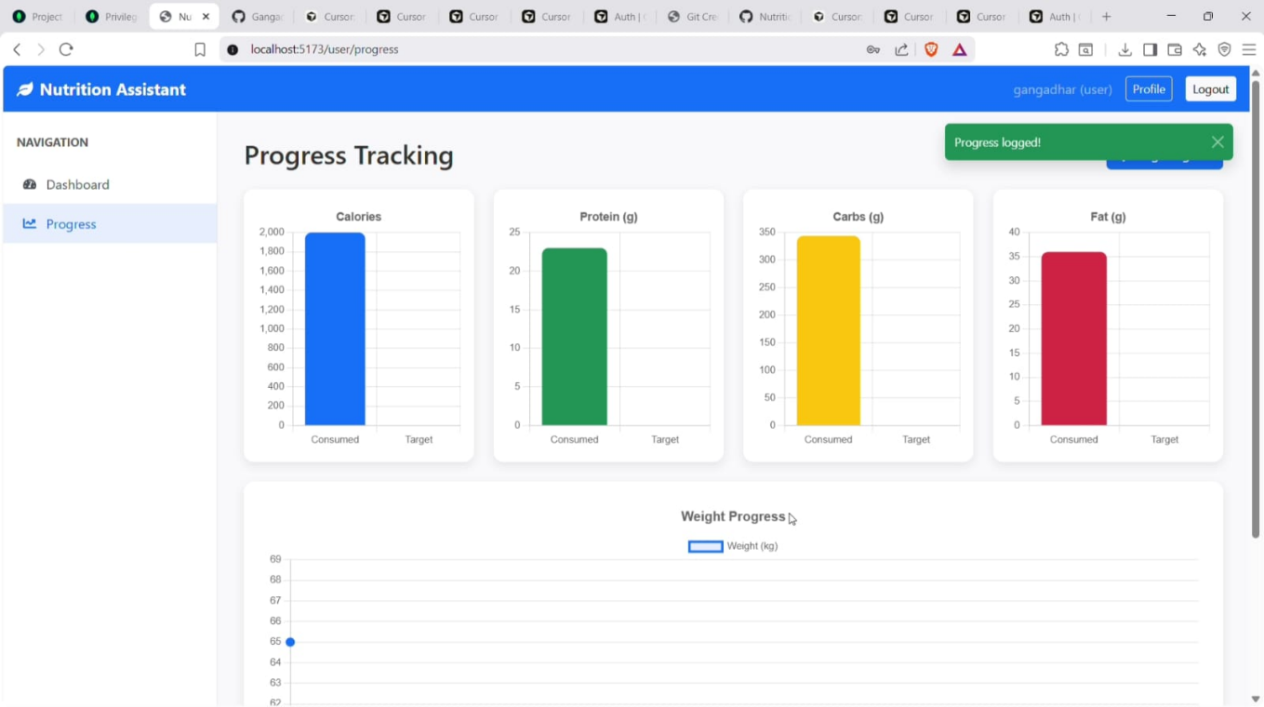

Figure 7.8: Project Website

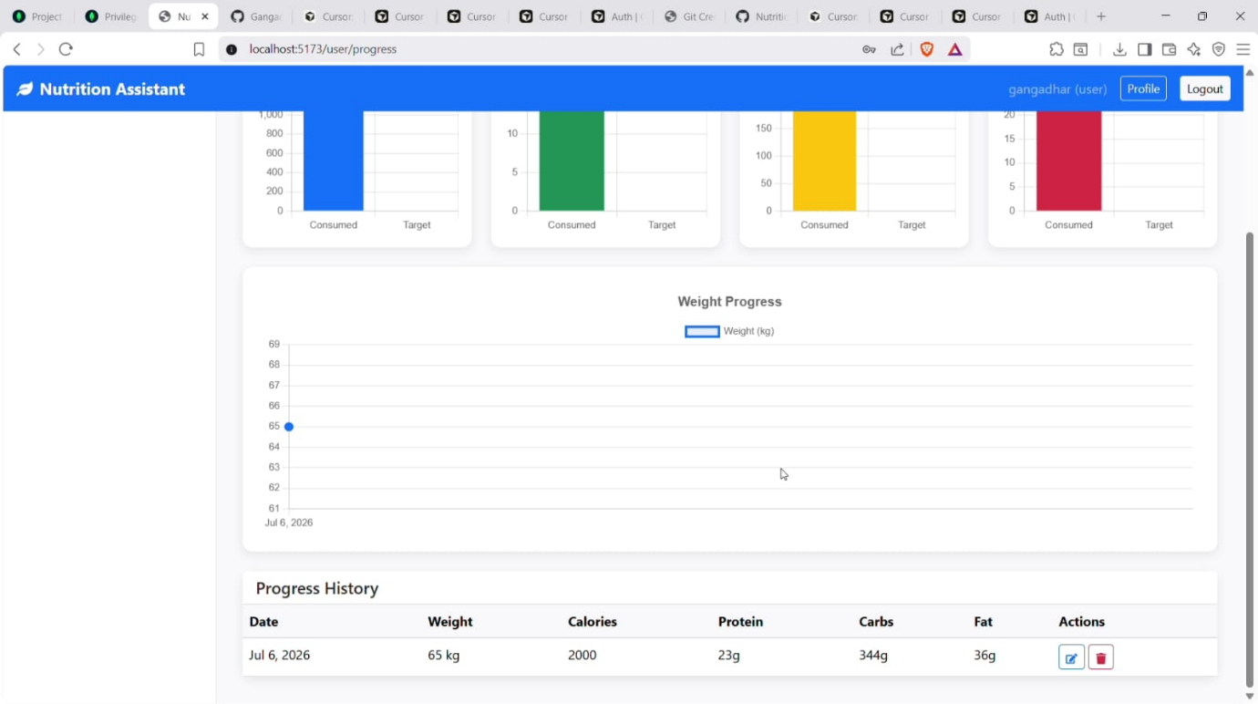

7.9: GitHub Repository

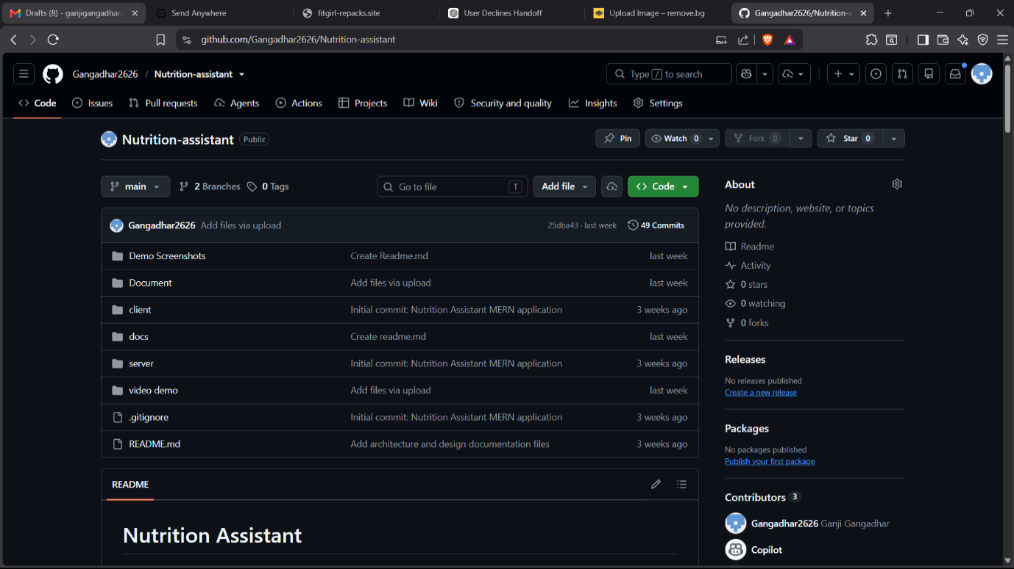

Figure 7.10: Tableau Public Dashboard

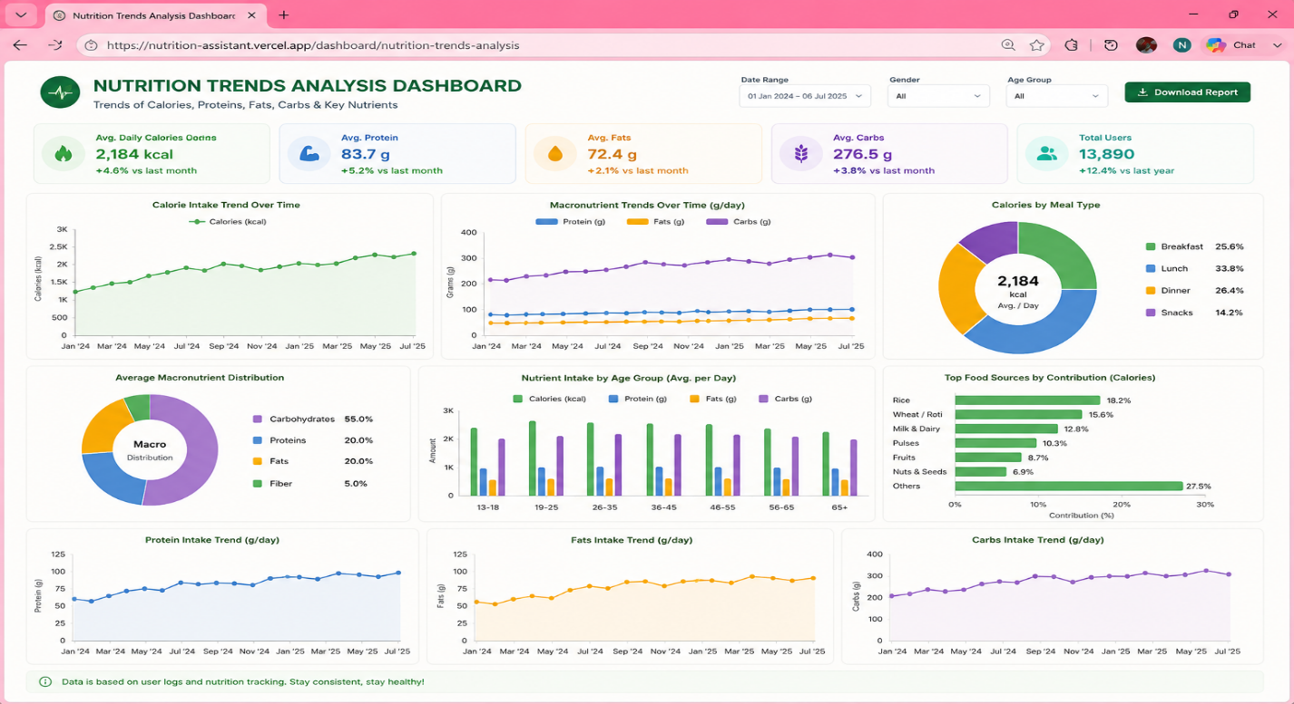
Result Summary
- Successfully developed the Nutrition Assistant using MERN Stack for personalized nutrition management.
- Implemented secure user registration, login, and authentication.
- Developed BMI and daily calorie calculation modules.
- Implemented daily nutrition tracking for calories, proteins, fats, carbohydrates, and other nutrients.
- Generated personalized AI-powered meal recommendations based on user health profiles and dietary preferences.
- Visualized calorie, protein, fat, carbohydrate, and nutrition trends through interactive dashboards and charts.
- Enabled users to monitor health progress using daily, weekly, and monthly reports.
- Successfully integrated MongoDB for secure storage and efficient retrieval of user nutrition data.
- Developed a responsive web application using React.js, Node.js, Express.js, and MongoDB.
- Successfully deployed the application for access through modern web browsers

Figure
- Implemented interactive filters for easy data exploration.
- Created a responsive web application for project presentation.
- Successfully deployed the project using Vercel and maintained the source code on GitHub.
- Generated meaningful insights to support data-driven decision-making in the agricultural sector.
8. ADVANTAGES & DISADVANTAGES

Advantages
The analysis is based only on historical data (1997–2021) and does not include real-time updates.
- Weather conditions and climate data are not incorporated into the analysis.
- Market price information and demand forecasting are not included.
- The project depends on the quality and completeness of the available dataset.
Tableau Public requires an internet connection to access the published dashboards

Disadvantages
- The accuracy of meal recommendations depends on the quality and correctness of the user-provided health information.
- AI-generated nutrition recommendations may not replace professional medical or dietician advice.
- The application requires a stable internet connection for accessing the web application and backend services.
- The food database may not include every regional or custom food item, which can affect nutrition tracking accuracy.
- Users must regularly update their meal logs to obtain accurate nutrition analysis and progress reports.
- The system currently focuses on nutrition management and does not integrate with wearable fitness devices or real-time health sensors.
- Personalized recommendations may require additional health parameters for greater accuracy.
- Continuous maintenance is required to keep the nutrition database, AI recommendation model, and application features up to date.

9. CONCLUSION
The Nutrition Assistant using MERN Stack project successfully demonstrates the application of modern web technologies, database management, and intelligent nutrition analysis in promoting healthier lifestyles. By integrating user health information, nutrition tracking, BMI calculation, calorie estimation, and personalized meal planning, the project provides valuable insights into users' dietary habits, nutritional intake, and overall health progress.
The interactive web application enables users to monitor daily calories, proteins, fats, carbohydrates, vitamins, and other essential nutrients while receiving AI-powered personalized meal recommendations based on their health goals and dietary preferences. The responsive dashboard and progress reports allow users to visualize their nutrition trends, monitor improvements, and make informed dietary decisions through an intuitive and user-friendly interface.
Overall, the project highlights the importance of technology-driven nutrition management and demonstrates how the MERN Stack can be used to develop secure, scalable, and efficient healthcare applications. By transforming health and nutrition data into meaningful insights, the application encourages healthier eating habits, supports informed lifestyle decisions, and contributes to improved long-term health and well-being.

Instant

10. FUTURE SCOPE
The Nutrition Assistant using MERN Stack project can be further enhanced by incorporating additional features and advanced technologies to improve user experience and provide more intelligent health recommendations. Some possible future improvements include:
- Integrate wearable fitness devices (such as smartwatches and fitness bands) for real-time health and activity tracking.
- Develop advanced AI and Machine Learning models for highly personalized nutrition and meal recommendations.
- Add barcode and QR code scanning for automatic food item recognition and nutrition analysis.
- Implement image-based food recognition using computer vision to estimate calories and nutritional values from food photographs.
- Build a dedicated mobile application for Android and iOS platforms to improve accessibility.
- Integrate with healthcare systems and electronic health records (EHR) for comprehensive health monitoring.
- Provide multilingual support to make the application accessible to users from different regions and languages.
- Enable real-time notifications and reminders for meals, hydration, exercise, and nutrition goals.
- Introduce social and community features, allowing users to share progress, participate in health challenges, and receive peer motivation.
- Develop predictive health analytics to identify nutritional deficiencies, monitor long-term health trends, and provide preventive health recommendations based on user data.

11. APPENDIX

Source Code
The complete project source code, including the website files, Tableau integration, and project documentation, is maintained in a GitHub repository for version control and collaboration.
GitHub Repository:

https://github.com/Gangadhar2626/Nutrition-assistant.git

